Outbound Caller ID Authorization Form

This document is to authorize 8x8 to use the above numbers as outbound caller line identification display; where __________________ will hold full responsibility of the use of the number(s).
Company Name

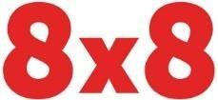
Customer Name:

Customer Address:

Number(s) to be displayed via 8x8:

In order to enable outbound caller ID Display for the above telephone number, 8x8 requires proof of ownership of the telephone numbers to be corroborated by a utility bill.

Non 8x8 number(s) - Yes / No Number(s) porting to 8x8 – Yes / No

Name of Company Representative: Title:
Signature: Date:

